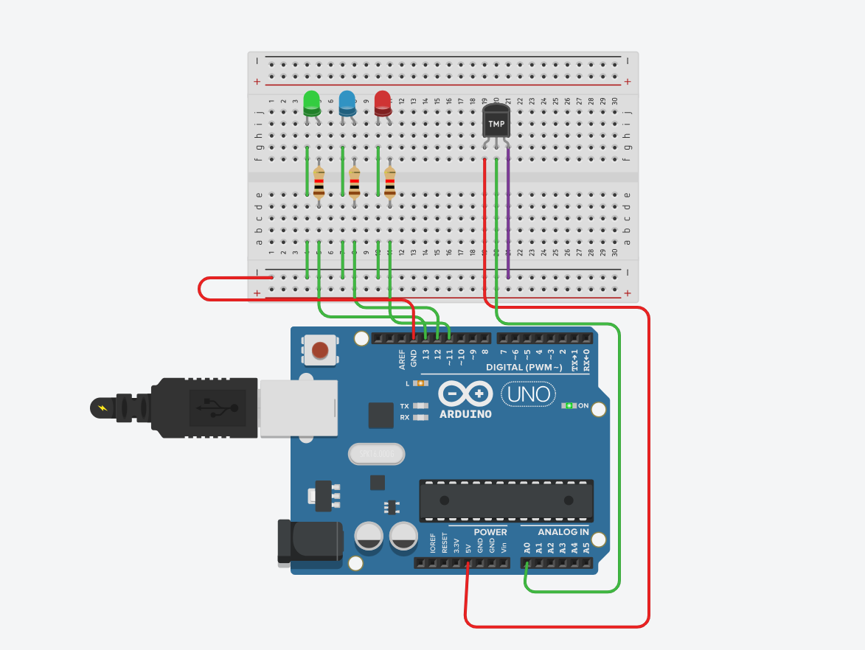

const int sensorPin = A0; // LM35 Temperature sensor output pin
const int greenLED = 13;
const int blueLED = 12;
const int redLED = 11;

void setup() {
pinMode(greenLED, OUTPUT);
pinMode(blueLED, OUTPUT);
pinMode(redLED, OUTPUT);

Serial.begin(9600);
}

void loop() {
int sensorValue = analogRead(sensorPin);

// Convert analog reading to voltage
float voltage = sensorValue * (5.0 / 1023.0);

// LM35: 10 mV per °C -> multiply by 100
float tempC = voltage * 100;

Serial.print("Temperature: ");
Serial.print(tempC);
Serial.println(" °C");

// LED Conditions
if (tempC < 40) {
digitalWrite(greenLED, HIGH);
digitalWrite(blueLED, LOW);
digitalWrite(redLED, LOW);
}
else if (tempC >= 40 && tempC < 50) {
digitalWrite(greenLED, HIGH);
digitalWrite(blueLED, HIGH);
digitalWrite(redLED, LOW);
}
else {
digitalWrite(greenLED, HIGH);
digitalWrite(blueLED, HIGH);
digitalWrite(redLED, HIGH);
}

delay(500);
}

